Task 1: Initialize Local Git Repository-
(git init, git add, git commit —
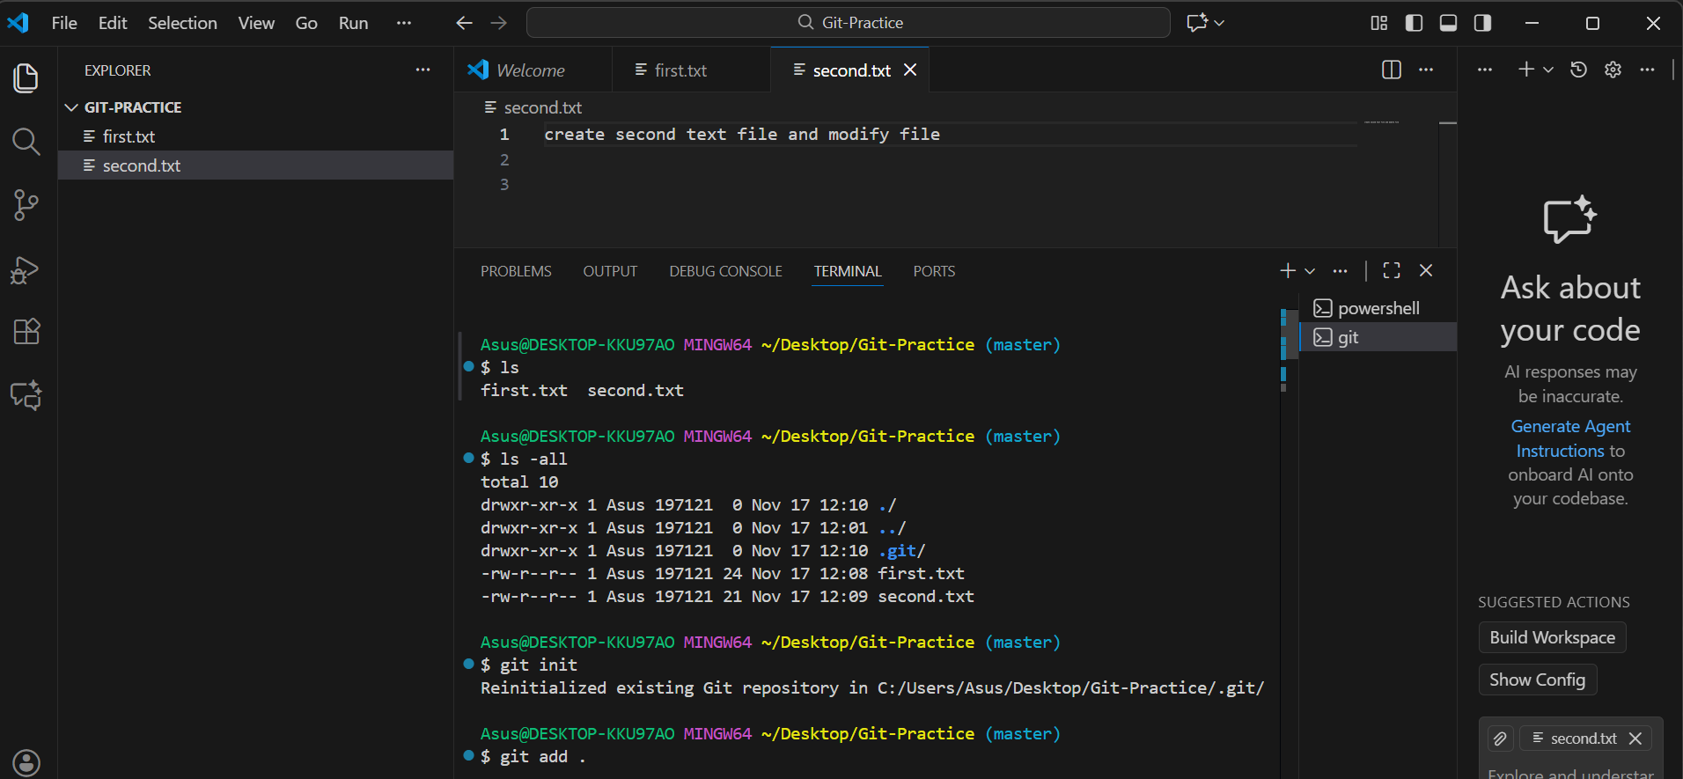
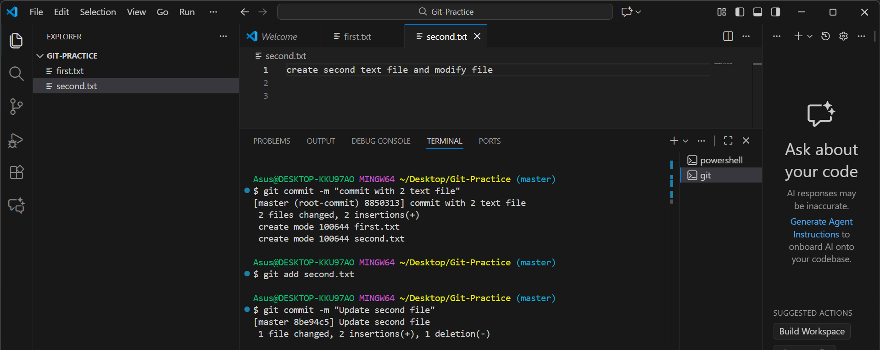
Task 2: Modify Files & View Commit History
(Screenshot: git log)
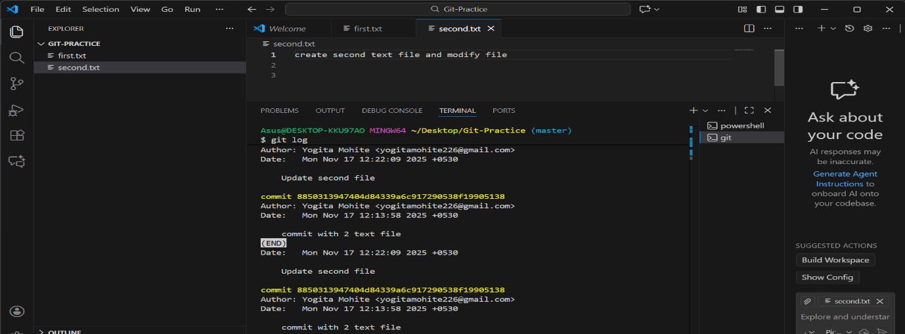

Task 3: Create New Branch & Merge into Main
(Screenshot: Branch list)
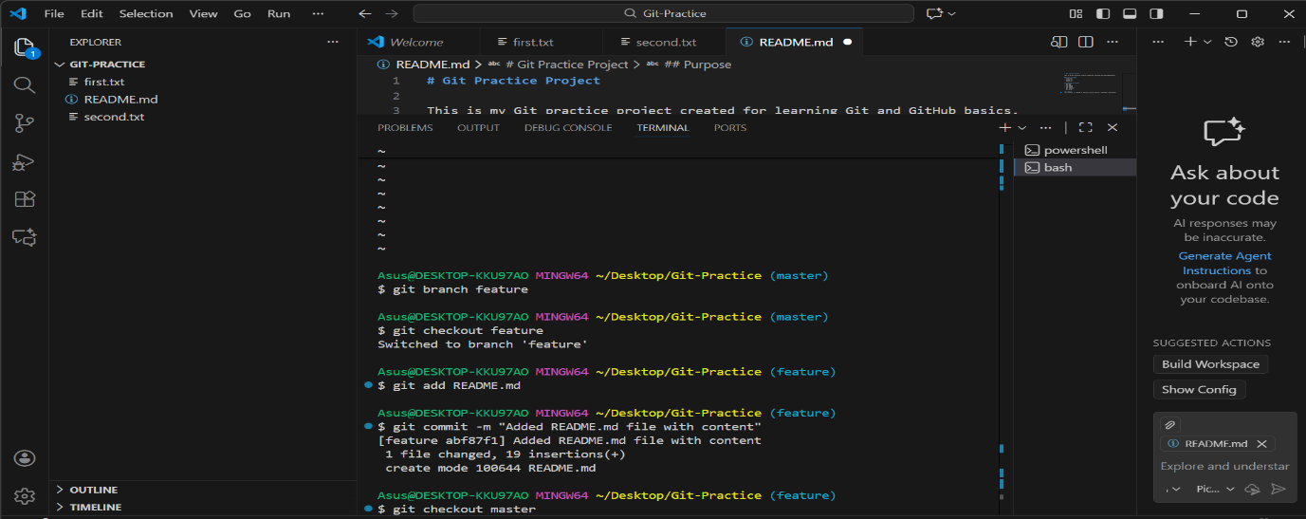
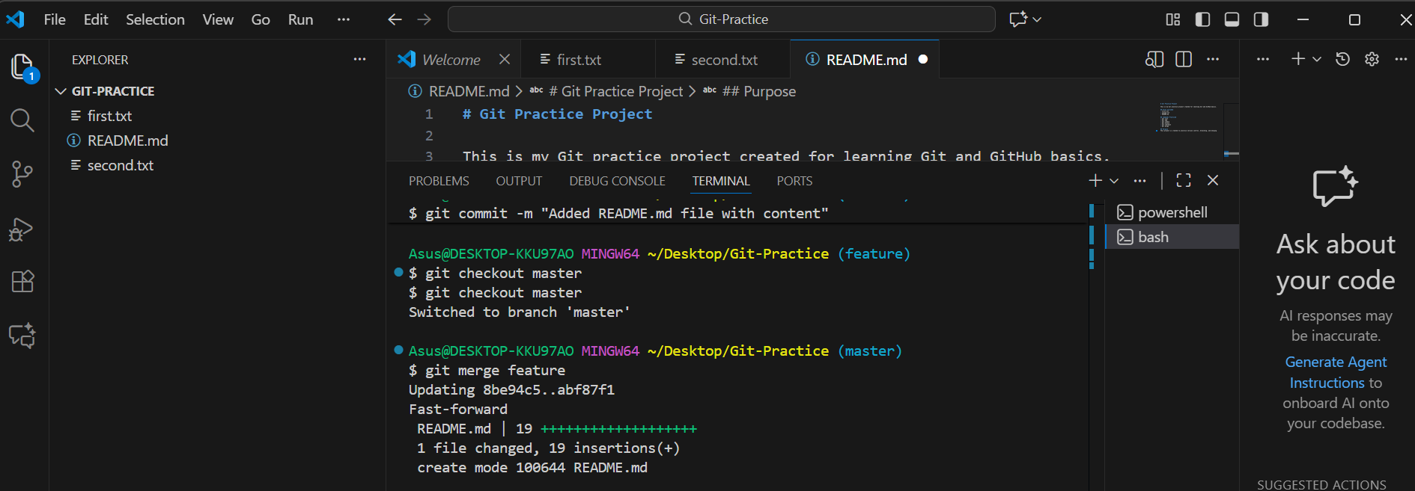
Task 4: Create GitHub Repository & Push Code
(Screenshot of GitHub repo)
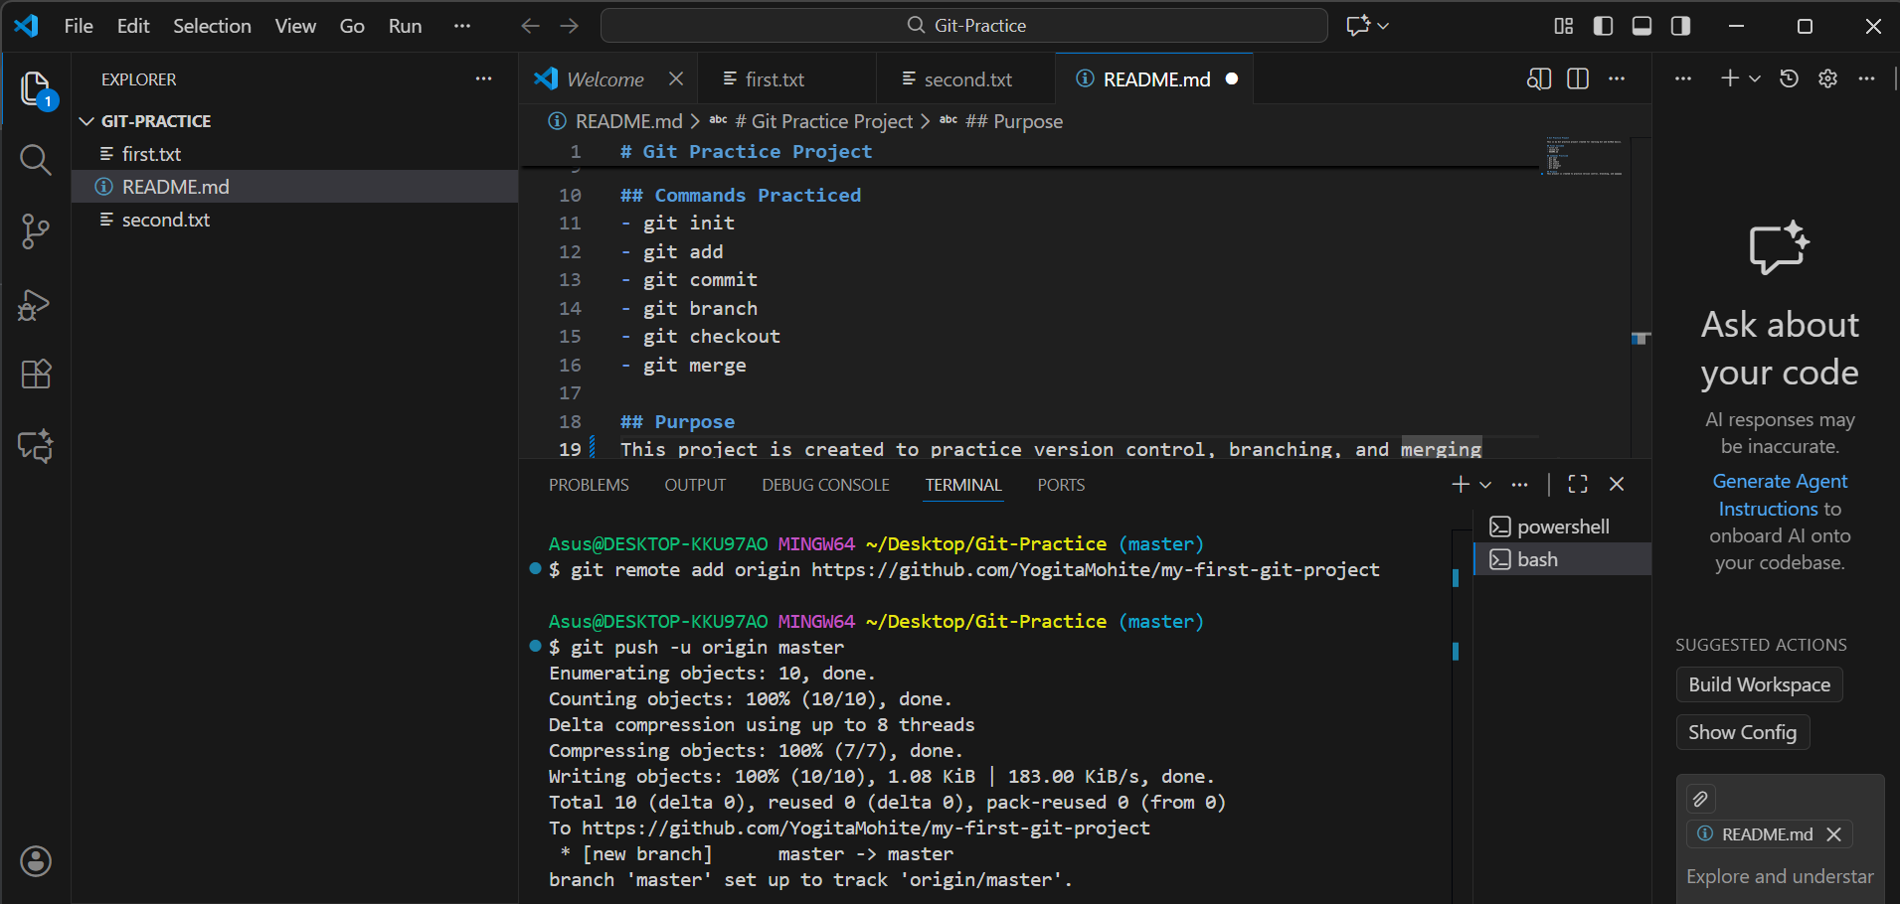
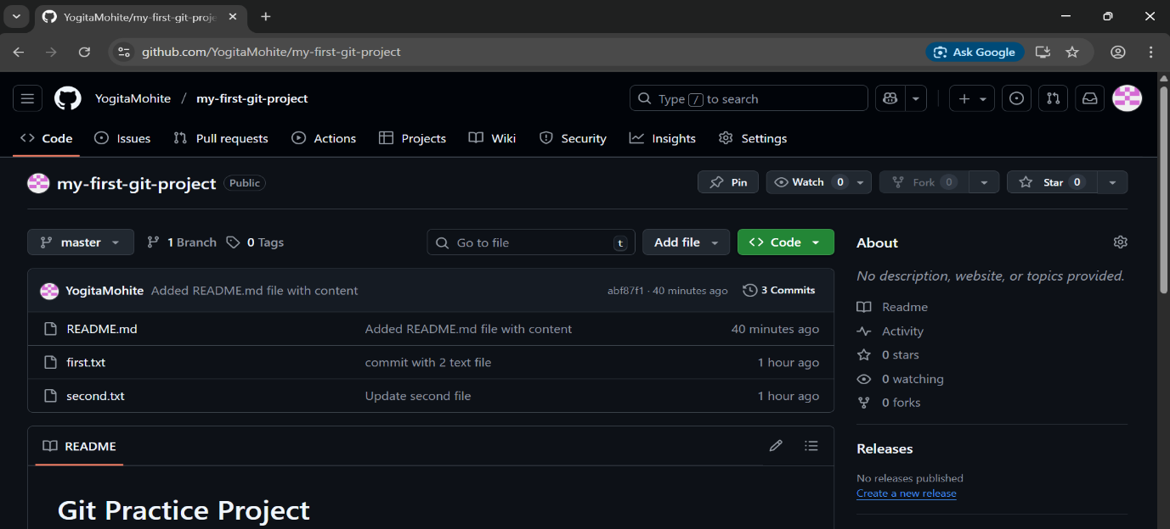
Task 5: Clone Repository & Add New File
(Screenshot: cloned repo + new file)
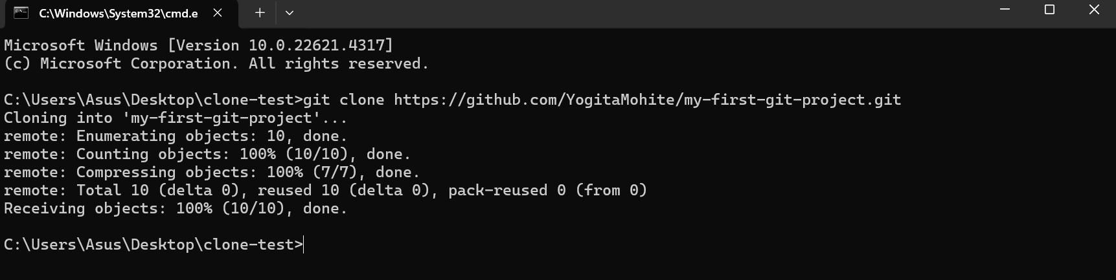
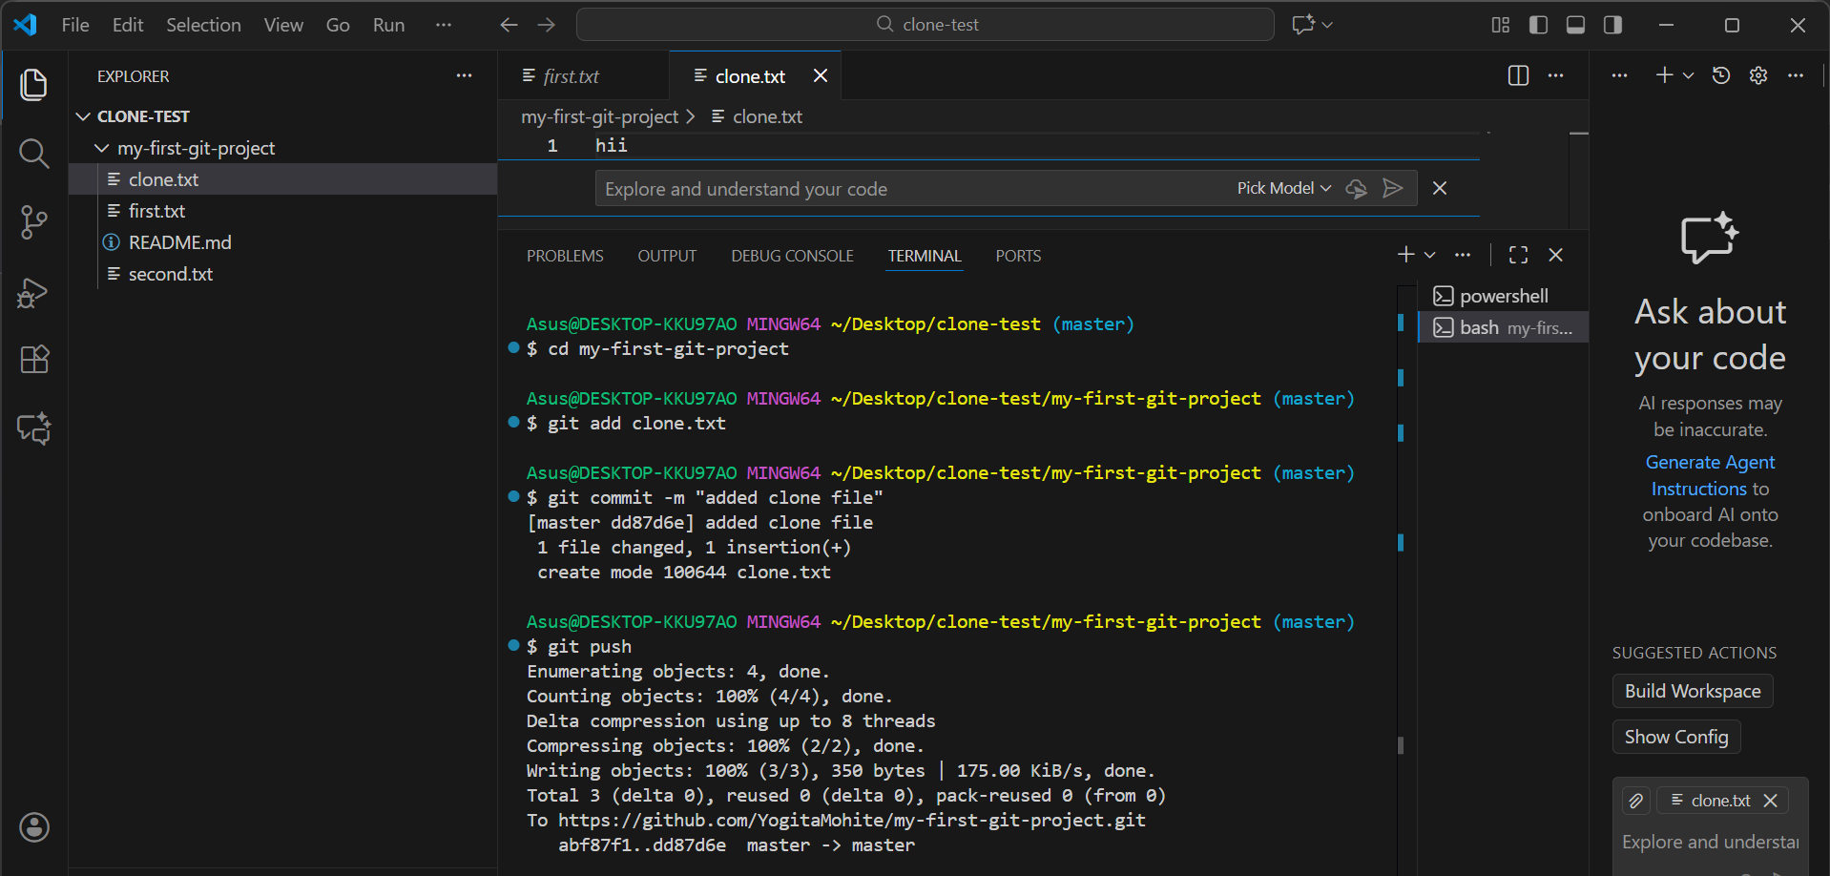
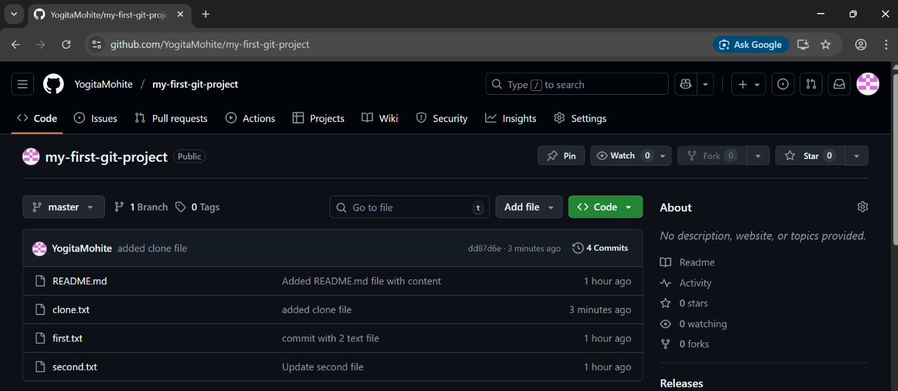
Task 6: Fork a Teammate’s Repository
(Screenshot: Forked repo page)
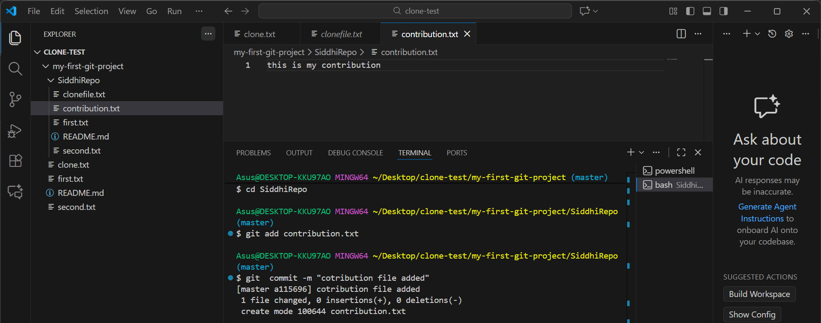
ask 7: Make Changes in Fork & Push
(Screenshot: commit pushed to fork)
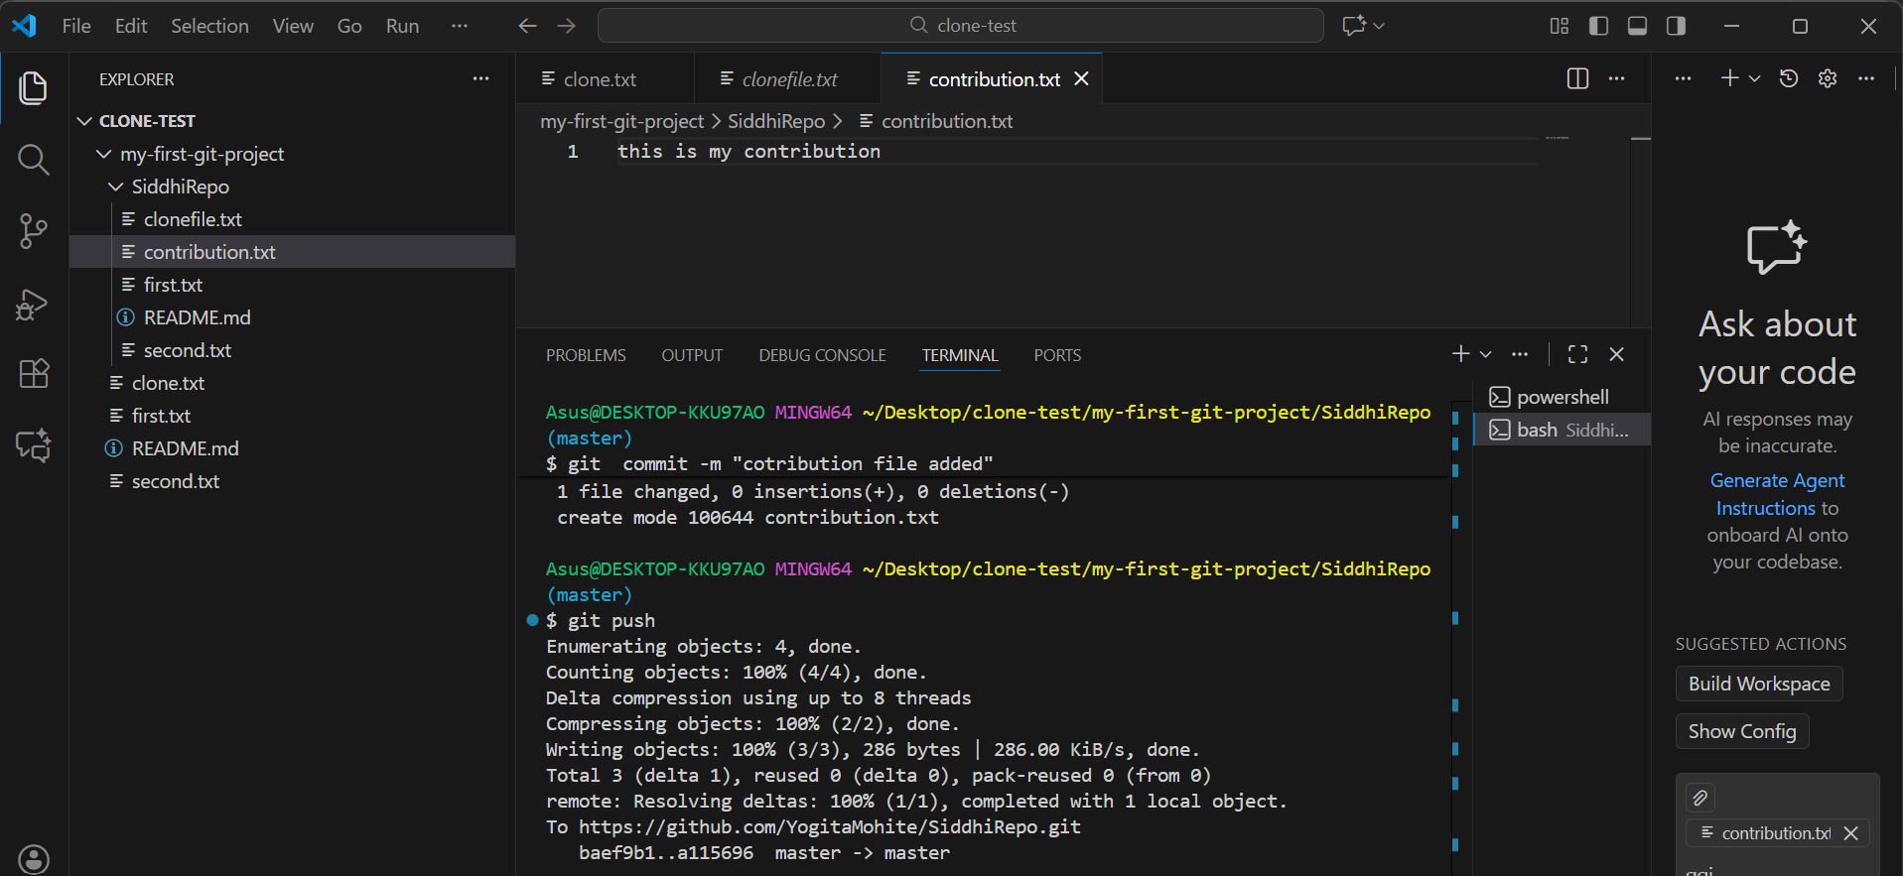
Task 8: Create Pull Request (PR)
(Screenshot: PR details page)
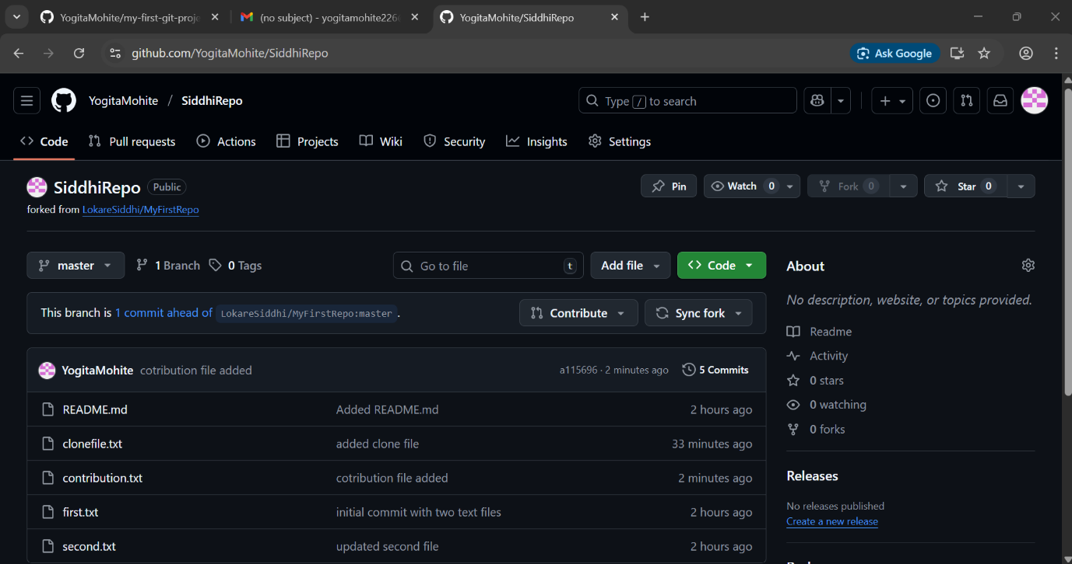
Task 8: Create Pull Request (PR)
(Screenshot: PR details page)
